**System.out.println in Java**

**class** System{

**static** PrintStream *out*;

}

* Difficulty Level : [Easy](https://www.geeksforgeeks.org/easy/)
* Last Updated : 28 Nov, 2019

Java **System.out.println()** is used to print an argument that is passed to it. The statement can be broken into 3 parts which can be understood separately as:

1. [System](https://www.geeksforgeeks.org/java-lang-system-class-java/)**:** It is a final class defined in the [java.lang package](https://www.geeksforgeeks.org/java-lang-package-java/).
2. **out:** This is an instance of [PrintStream](https://www.geeksforgeeks.org/java-io-printstream-class-java-set-1/)type, which is a public and static member field of the [System class](https://www.geeksforgeeks.org/java-lang-system-class-java/).
3. [println()](https://www.geeksforgeeks.org/difference-between-print-and-println-in-java/)**:** As all instances of [PrintStream class](https://www.geeksforgeeks.org/java-io-printstream-class-java-set-1/) have a public method println(), hence we can invoke the same on out as well. This is an upgraded version of print(). It prints any argument passed to it and adds a new line to the output. We can assume that System.out represents the Standard Output Stream.

[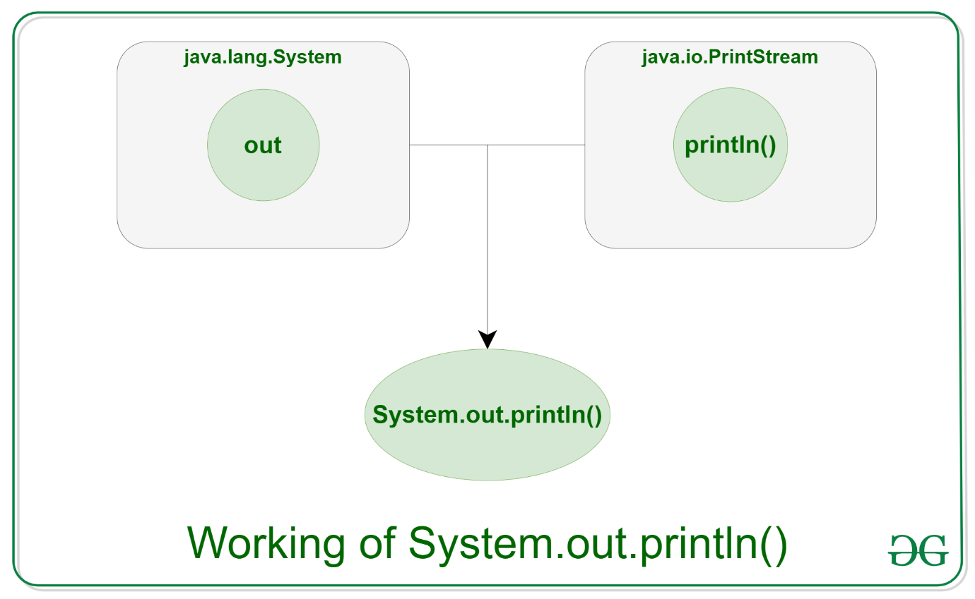](https://media.geeksforgeeks.org/wp-content/uploads/20191126171503/println1.png)

**Syntax:**

System.out.println(*parameter*)

**Parameters:** The parameter might be anything that the user wishes to print on the output screen.

**Example 1:**

|  |
| --- |
| // Java code to illustrate  // System.out.println();    **import** java.io.*;    **class** GFG {  **public** **static** **void** main(String[] args)      {          System.out.println("Welcome");          System.out.println("To");          System.out.println("GeeksforGeeks");      }  } |

**Output:**

Welcome

To

GeeksforGeeks